Dr. Nikita Zakharov

Institute of Economics

Department of International Economic Policy

University of Freiburg

Winter semester 2023/24

First Exam

Introduction to Empirical Economics Using Stata

Access to justice and economic development: Evidence from an

international panel dataset

(Arnaud Deseau a, Adam Levai b, Michèle Schmiegelow)

**Exercise 1 (20 points)**

[DESCRIPTIVE STATISTICS.]

The paper introduces a novel dataset on the number of judges per capita, which essentially measures access to formal justice. Figure 2 shows trends in the number of judges per 100,000 inhabitants between 1970 and 2019, in five-year averages, for 105 countries grouped into eight regions, plus the world average. While the graph convincingly highlights the heterogeneity in access to justice by the world regions, there is an alternative approach to plot the time trends and variation in the variable between the countries in each subgroup by using the box plots. Your task is to replicate time trends from Figure 2 using the Stata command "graph box" for each world region separately. Some world regions have too few countries to construct a box plot – thus, you need to combine them with a respective neighboring region. Your report must indicate how your results differ from the original graph and why.

Our goal is to replicate the trends in the number of judges per 100,000 inhabitants (a measure of access to justice) between 1970 and 2019, using box plots for each region.

To achieve this, we created the region variable and generated box plots for each region to illustrate the differences in judges' per capita growth from 1970 to 2015. We merged regions in Asia and the Americas because some regions had too few countries to generate meaningful box plots on their own.

The results show an increase in the number of judges in the **Middle East & North Africa** region. While the increase is not highly significant, all regions seem to exhibit similar growth patterns in the number of judges. In **America** and **Sub-Saharan Africa**, however, there is no noticeable increase in judges per capita. **Asia** shows a slight increase, but there are notable outliers, such as **Japan**. The greatest growth in the number of judges is observed in **Europe (non-transition economies)** and **Transition Economies** in Europe, with these regions also exhibiting greater variance across countries.

The key difference between our graph and the original is that our method highlights the variance between countries and clearly depicts outliers. Although, for instance, by merging regions, such as in **South Asia**, we lose valuable information about the lack of growth in that specific region. The merging of South Asia with the rest of Asia could create the impression that this region is experiencing growth as well, when in fact, it may not be.

Jaime Alvaredo del Pino

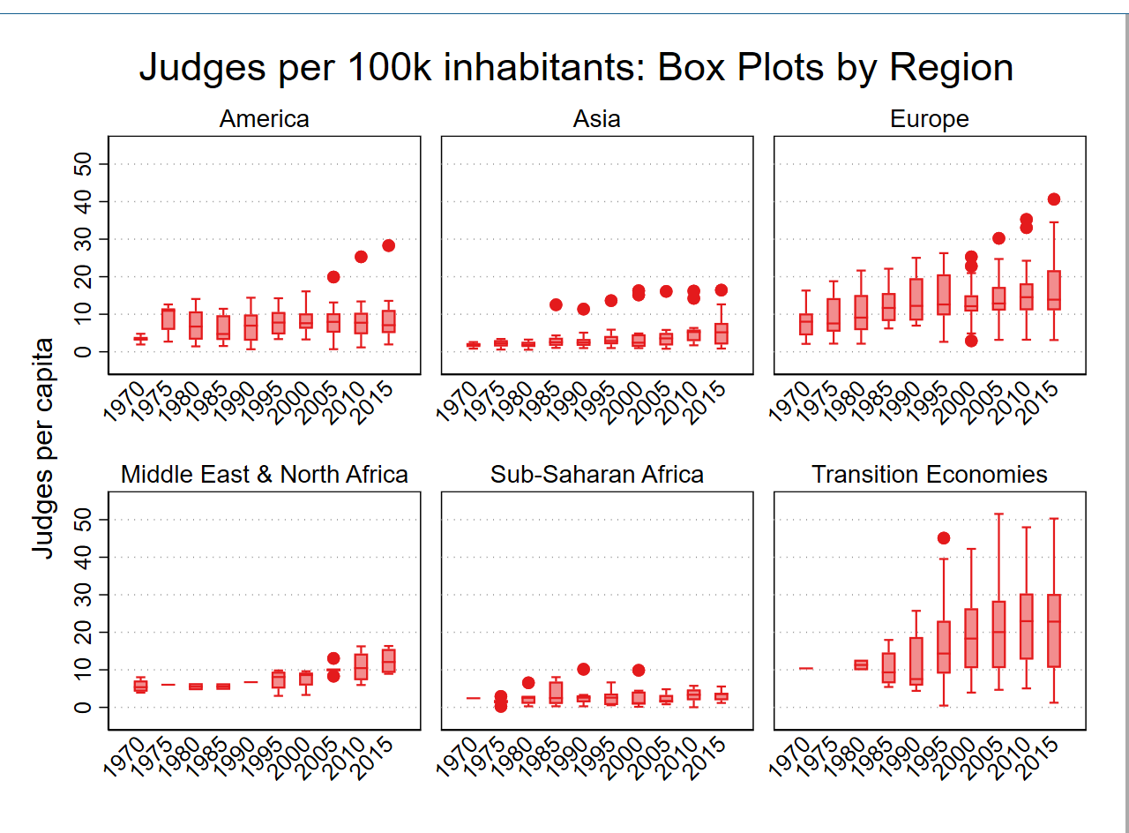

Deseau, A., Levai, A., & Schmiegelow, M. (2024). *The evolution of judges per capita across regions between 1970–2019*. In *Access to Justice and Economic Development: Evidence from an International Panel Dataset*.

Figure 2: The evolution of judges per capita across regions.

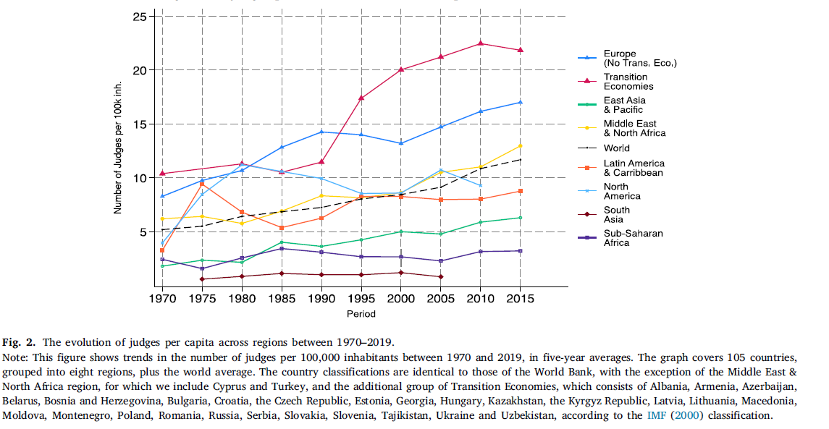

Exercise 2 (20 points)

[PLOTTING COEFFICIENTS.]

The main results of the paper are presented in Table 2. Notice that estimations are performed using the two-way fixed effects OLS (OLS-FE) model and the difference Generalized Method of Moments estimator (GMM). There is a clear difference between the two estimation techniques and in their coefficients in Columns 1 (OLS-FE) and 2 (GMM). Your replication task is to perform the estimations for all five specifications (as in Columns 2-6) using OLS-FE (in your own coding) and GMM models (as in the paper's code). Then you must plot the coefficients within one graph in such a way that a reader could compare them visually. In the output file, you need to discuss the differences between the coefficients from OLS-FE and GMM (for each specification).

Use the "coefplot" command. Do not forget to account for the time and country fixed effects in OLS-FE regression. Include appropriate titles and notes within the figure. Discuss the overlap of the confidence intervals and provide statistical tests of the differences between the coefficients.

The goal of this exercise is to replicate the results from the paper, comparing the coefficients on **log(judges per capita)** across different model specifications, using both **OLS-FE** and **GMM** estimations. The comparison of these coefficients are visualized through a **coefficient plot**.

The **coefficient plot** displays the estimated coefficients for L. Ln_judgespc and their **95% confidence intervals**. The **x-axis** represents the coefficient estimates, while the **y-axis** lists the different specifications. Each specification shows two points for the coefficient: one for **OLS-FE** (in blue, red, green, etc.) and one for **GMM** (in blue, red, green, etc.).

* The GMM always gives a bigger estimate and also a higher variance as the CI range is significantly bigger than the OLS-FE one.
* The last two specifications overlap both estimates meaning that they are not statistically different.

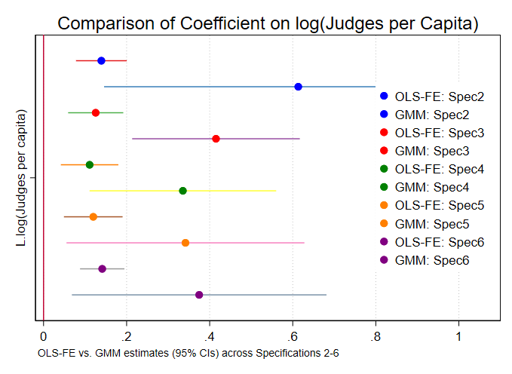

*Comparison of Coefficients on log(Judges per Capita) OLS-FE vs GMM*. In *Access to Justice and Economic Development: Evidence from an International Panel Dataset*. Jaime Alvaredo Del Pino

Exercise 3 (20 points)

[DATA PREPARATION / DESCRIPTIVE STATISTICS.]

In this exercise, you must import additional variable(s) to your replication dataset. Go online and obtain the panel data from the Variety of Democracy project (link: https://www.v-dem.net/data/the-v-dem-dataset/). You need to choose and add one additional variable from the V-Dem dataset using the "merge" command in your do-file. Note that the dataset has over 200 indices, and you are free to choose any of them, but you need to explain your choice in the output file (also, please do not choose public corruption or Polity2 variables since they are already present in Deseau et al. (2024) data). Once the data merging is complete, draw a new

4

world map showing the new variable's geographic distribution (similar to Figure 1). Provide some discussion based on the map in your report (pdf file).

Hint: Do not forget that data in Deseau et al. (2024) are averaged over 5-year intervals. Do not forget to hand in the dta file for the V-Dem variable for merging (you do not need to upload the whole V-Dem file – you can transform the dta file to include only necessary variables).

The **map** displays the **mean level of religious freedom** (v2clerelig) for each country over the available periods, based on data from the **V-Dem dataset**. The **color scale** indicates the level of freedom, with **darker blue colors** corresponding to higher levels of religious freedom, and **lighter shades** representing lower levels. Countries with missing data are excluded from the map.

This visualization helps to understand the **geographical distribution** of religious freedom across the world, showing clear **regional patterns**. For example, **North America** and **Europe** tend to have higher levels of religious freedom, while certain regions in **Africa** and **Asia** display lower scores, highlighting the disparities in freedom of religion globally.

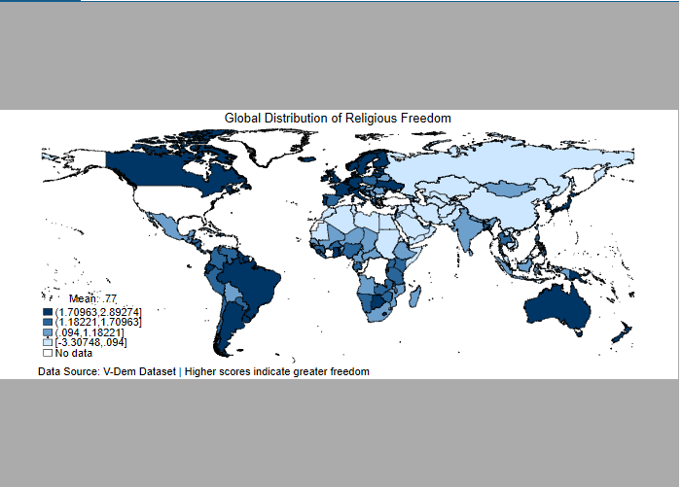

Note: The **color scale** ranges from light blue (lower freedom) to dark blue (higher freedom), providing a visual comparison across regions. **Mean value: 0.77**.

Exercise 4 (20 points)

[REGRESSION ANALYSIS / TABULAR OUTPUT.]

For this exercise, use the newly added variable from the V-Dem data as a dependent variable (instead of economic growth) to investigate how it is affected by the access to justice measured by the number of judges per 100,000 inhabitants (𝑙𝑜𝑔(𝐴𝑇 𝐽)𝑡−1). Provide all necessary estimations in one table. Structure the results to make a convincing story about the effect and its robustness to alternative specification and placebo tests. Explain the main findings in the report (pdf file).

Hint: Do not just copy a table from the paper; develop a unique customized table that tells a story. You can still use regressions from the original code.

I did not manage to use the merged variable for a new regression. The code in DO-File would not work so I decided not to include it.

Exercise 5 (20 points)

[HETEROGENEOUS EFFECTS / PLOTTING MARGINAL EFFECTS.]

In the subsection "4.3. Heterogeneous effects of ATJ on economic development ", Figure 4 demonstrates the marginal effects of ATJ on economic growth at different levels of per capita GDP. This exercise consists of two parts:

a) Replicate the heterogeneous analysis as in Figure 4 separately for countries considered democracies and countries with non-democratic regimes. It is your task to decide how to categorize countries into those two groups, but you need to support your choices with appropriate references to the literature (hint: find and cite 1-2 papers that do something similar). You are free to choose how to conduct the heterogeneous effect analysis but provide the plot(s) of the marginal effects of ATJ on economic growth by the level of democracy. In your report, you must explain your approach, justify the democratic/non-democratic split, and describe the main findings.

In this analysis, we aim to examine the heterogeneous effects of **Access to Justice (ATJ)** on **economic growth** by categorizing countries into two distinct groups: **Democracies** and **Non-Democracies**. This classification is central to understanding whether the impact of **ATJ** varies depending on a country's political regime.

The categorization of countries into **Democracies** and **Non-Democracies** is based on the widely-used **Polity2 score** from the **Polity IV Project**. This score measures the **level of democracy** in a country, ranging from -10 (strongly autocratic) to +10 (strongly democratic). According to the literature, a common threshold for classifying democracies is a Polity2 score greater than 5, while scores equal to or below 5 are typically categorized as **Non-Democracies**.

* **Democracies**: Countries with a Polity2 score greater than 5, indicating a political system with substantial democratic practices such as regular competitive elections, civil liberties, and political pluralism.
* **Non-Democracies**: Countries with a Polity2 score of 5 or less, indicating political systems characterized by limited political competition, centralized power, and potential restrictions on political freedoms and civil rights.

One notable reference that supports this approach is **Haggard and Kaufman (2012)**, who use the **Polity2 score** in their analysis of the relationship between political regimes and economic performance. Another reference is **Acemoglu et al. (2019)**, who examine the causal relationship between political institutions and economic growth.

**Democracies**: The effect of **ATJ on economic growth** is **negative** for countries with lower GDP per capita and **weakens** as GDP increases. This suggests that **democratic institutions** might be better suited to leverage judicial reforms and other ATJ improvements for economic growth, particularly in wealthier nations.

**Non-Democracies**: For **non-democratic countries**, the effect of **ATJ on economic growth** is **stronger** for countries with lower GDP per capita but becomes **less significant** as the economy grows. This implies that **non-democratic regimes** might benefit more from **ATJ improvements** at lower levels of economic development, but their governance systems might be less effective at translating judicial improvements into long-term growth once the economy reaches a certain threshold.

The heterogeneous effects of **ATJ on economic growth** vary significantly depending on the level of democracy. In **democratic countries**, the effect of ATJ is weaker in high-income countries, potentially due to existing institutional frameworks. In contrast, in **non-democratic countries**, ATJ seems to have a more significant impact on growth in low-income countries, though its effectiveness diminishes as economies become wealthier.

The findings suggest that **ATJ reforms** can play a crucial role in fostering economic growth, but their effectiveness may depend on the type of political regime. This emphasizes the importance of **political institutions** in shaping the outcomes of justice and governance reforms.

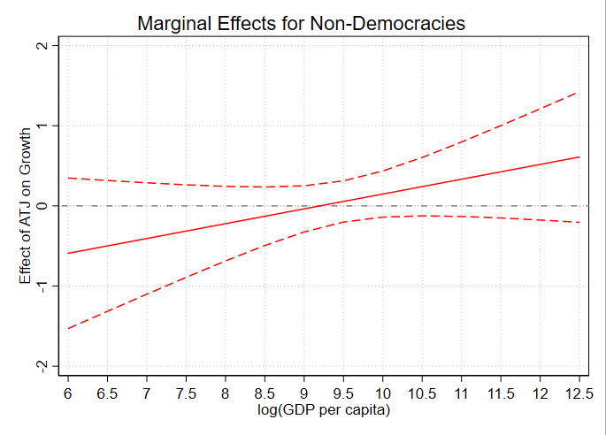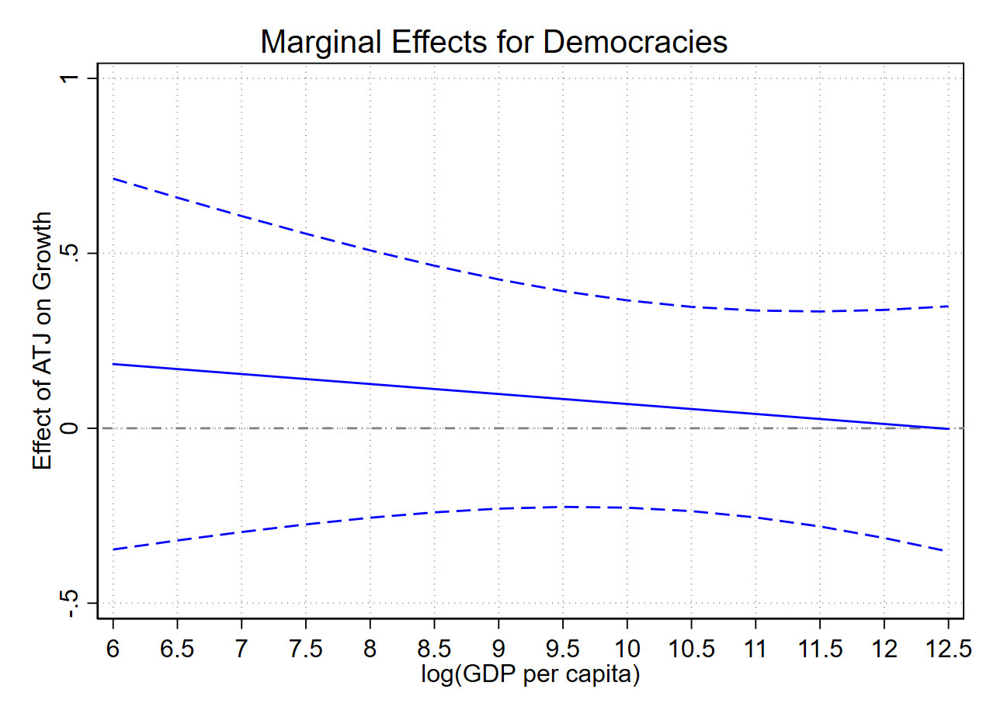

### **References:**

* Haggard, S., & Kaufman, R. R. (2012). *Democracy, Inequality, and Governance: A Comparative Perspective*. Cambridge University Press.
* Acemoglu, D., Johnson, S., & Robinson, J. A. (2019). *The Colonial Origins of Comparative Development: An Empirical Investigation*. American Economic Review, 91(5), 1369-1401.